INSTRUCTION TO FLASH STM32

- Download and install STM32CubeIDE and STM32CubeProgrammer from official website
- Connect the probes from ST-LINK/V2 debugger in manner as shown in the image below:
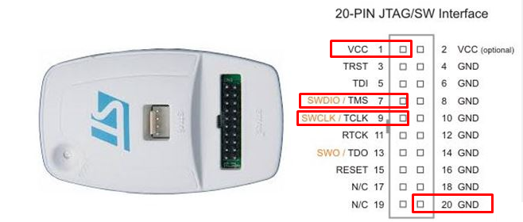
- Once the connections are made and verified, open STM32CubeProgrammer and choose ST-LINK from Top Right corner of the screen.
- Refresh the Serial Number section in ST-Link Configuration menu and select your ST-LINK
- Port should be SWD, Frequency should be 4000KHz, Reset Mode should be Software Reset. Rest of the options can be left default
- Click Connect to connect to the ST-Link Debugger and verify successful connection.
- Click on Download button on the left corner of the screen. This will open Erasing and Programming menu.
- Select binary .elf file from the browse menu. Check mark Verify Programming and click Start Program to start flashing.
- Once successful, reboot Ezlo Aware and observe Sound UI Tile behavior.

